Lecture 10.

Basics of clinical microbiology. Healthcare-associated infections. Infections of the respiratory tract, gastrointestinal tract, urogenital tract, central nervous system, wound and septic infections

The purpose of the lecture: To acquaint students with the goals and objectives of clinical microbiology. Educate them about healthcare-associated infections. To provide information about the causative agents of respiratory tract, gastrointestinal tract, genitourinary tract, central nervous system and wound infections and principles of disease diagnosis. To acquaint students with the principles of microbiological diagnosis of healthcare-associated infections and septic infections.

Lecture plan:
1. The concept of clinical microbiology. Information on healthcare-associated infections. Infection Control.
2. Upper and lower respiratory tract, brief anatomical and physiological information
- Normal microflora of the upper respiratory tract, inflammatory diseases and their causes, rules for taking pathological material, principles of microbiological diagnosis
- Inflammatory diseases of the lower respiratory tract, their types, causative agents, principles of microbiological diagnosis.
3. Gastrointestinal tract, brief anatomical and physiological information
- Concepts of normal microflora of the gastrointestinal tract, dysbiosis and dysbacteriosis
- Inflammatory diseases of the gastrointestinal tract and their causes, principles of microbiological diagnosis
- Criteria and microbiological diagnosis of dysbiosis
4. Central nervous system, brief anatomical and physiological information
- Inflammatory diseases of the brain and meninges, meningitis, encephalitis, causative microorganisms, principles of microbiological diagnosis.
5. Urinary tract and genitals, brief anatomical and physiological information
- Normal microflora of the genitourinary tract, inflammatory diseases and their causative agents.
- Microbiological examination of urine. Bacteriuria, its determination and evaluation.
- Sexually transmitted diseases.
- Inflammatory diseases of female genital organs, microbiological examination methods.
- Understanding of TORCH infections. Transplacental diseases and their diagnosis.
- Inflammatory diseases of male genital organs, microbiological examination methods.
6. Inflammatory diseases of the skin. Complicated infections during skin lesions.
- Wound infections, microbiological diagnosis.
7. Sepsis, causative agents of septic infections, principles of microbiological diagnosis.

Diagnostic Microbiology
The clinical microbiology laboratory plays an important role in the diagnosis and control of infectious diseases. Newer molecular, proteomic, and immunologic technologies are being used to enhance the information that the laboratory can provide. Many of the diagnostic tests require viable samples, and the quality of the results depends on the quality of the specimen collected from the patient, the means by which it is transported from the patient to the laboratory, and the techniques used to demonstrate the microbe in the sample. In addition, the collected specimen must be representative of the site of infection and not contaminated during collection with other organisms that colonize skin and mucosal surfaces. Antimicrobial susceptibility determinations require viable and representative microbes purified from the clinical sample. Knowing the minimal inhibitory or biocidal concentrations for specific drugs is important for prescribing
the best treatment. The procedures for genome and antigen analysis have
become less expensive and available for more pathogens.
These procedures may not require viable samples. These
assays are very sensitive and specific and can speed up the
analysis.
Relatively few organisms are classified as always pathogenic (e.g., rabies virus, Bacillus anthracis, Shigella, Sporothrix schenckii), whereas some establish disease only under well-defined circumstances or under certain conditions (e.g.,opportunistic infections of immunocompromised individuals). Some diseases arise when a person is exposed to organisms from external sources, which is called an exogenous infection (e.g., influenza virus, C. tetani, Neisseria gonorrhoeae, Coccidioides immitis, and Entamoeba histolytica), but most human diseases are produced by organisms from the person’s own microbial flora that spread to normally sterile body sites (e.g., blood, brain, lungs, peritoneal cavity) in which disease can ensue (endogenous infections).
Some infections cause a single well-defined disease, which is oftentimes caused by the action of a virulence factor, such as a toxin (e.g., C. tetani [tetanus]), whereas others can cause several manifestations of disease (e.g., Staphylococcus aureus causes endocarditis, pneumonia, wound infections, food poisoning). The same disease can also be caused by different microbes (e.g., meningitis can be caused by viruses, bacteria, fungi, and parasites). By understanding the characteristics of the microbe and the host’s response to infection, a Sherlock Holmes–like approach can be applied to the microbial villain to solve the clinical infectious disease case. In addition, proper precautions can be taken to protect oneself and others from infection, and a sensible approach to prescribing appropriate therapy can be designed. When approaching a patient with an infectious disease, there are four questions that must be answered. Question 1 and the first step in treating an infectious disease is to recognize and distinguish an infection from other maladies. Infections are often accompanied by fever, inflammation, swollen lymph nodes, and other symptoms. Many of these disease presentations are caused by the inflammatory response to the infection. These same presentations can be induced by other disease syndromes. The next question is, where is the infection? Knowing the site of infection can provide clues as to the possible microbes causing the infection and is important in picking an antimicrobial that can reach the infected tissue or site. The answers to Question 3 are the main subjects of this book: Which microbe is causing the infection and how is it causing the disease? Although the distinction of bacterial, viral, fungal, and parasitic infections can oftentimes be made from the history and physical presentations of the patient, certain laboratory tests can help focus the diagnosis. For example, bacterial infections are often accompanied by increases in serum levels of C-reactive protein and procalcitonin, which are components of an inflammatory response. Once a differential diagnosis (a list of most probable villains) is obtained, then confirmatory tests can identify
the disease-causing microbe. Introduce the different types of tests and their application to each of the microbes to be discussed. In addition to knowing the most appropriate test for a microbe or microbial syndrome, it is also important to know the limitations, sensitivity, and specificity of the tests. More and more individuals are living with immunodeficiencies caused by treatments for cancer, autoimmune diseases, or infections (e.g., AIDS). These individuals become
susceptible to infections caused by less virulent or nonvirulent microbes that do not affect other individuals. The importance of the deficient immune response becomes very apparent for protections against these microbes. Bacterial disease is usually determined by the microbe’s virulence factors. For some, it is a one–one correspondence, such as for toxin-producing Corynebacterium diphtheriae, Vibrio cholera, and C. botulinum. For others, the disease may result from colonization, toxic by-products, or the immune and inflammatory responses to the microbe. Immune and inflammatory responses are triggered by structures of the microbe. Repetitive microbial structures provide pathogen-associated molecular patterns that induce innate responses, whereas specific structures are recognized by the immune response. In addition, extracellular bacterial and fungal structures usually trigger the activation of a cascade of soluble proteins of the complement system, which recruits macrophages and neutrophils to the infection site, initiates inflammation, activates antibody production, and generates a molecular membrane pore in the microbe. Intracellular infections, including viruses, bacteria, fungi, and parasites, require a different immune response, and the consequences are also different. Human cells respond to an intracellular microbial infection by shutting down cellular processes and by activating cytolytic cellular responses (natural killer [NK] cell, T cell, and macrophage responses) that kill or wall off the infected cells. Antibody is generated to inactivate toxins, to prevent binding of the microbe, and to facilitate its uptake and clearance by macrophages and neutrophils. The nature of the disease and susceptibility of an individual to a pathogen is determined by how soon the protective response can act on the infection, the efficacy of the response, and the immunopathologic consequences of that response. Inflammation accompanies most immune responses and sometimes it is just as important to treat the inflammation as it is to treat the infection to reduce the severity of the disease.
The fourth question should take considerable thought:
Should the microbe be treated and, if so, what is the best treatment? Designing appropriate therapy is necessary for those infections that do not resolve on their own. Although safe, antibiotic treatment can disrupt the normal flora which
may allow more pathogenic bacteria or fungi to take their place. Proper therapy requires getting enough of the right antimicrobial drug to a sensitive target within the microbe at the site of infection in the body. The antimicrobial potency and spectrum of activity and the pharmacologic properties of the drug are determined by the structure and mode of action of the drug. Microbes may be naturally resistant, mutate, or acquire genetic information to make them resistant and those that are resistant to antibiotics will be selected and will endure. Initial antimicrobial choices may attempt to cover all possible pathogens, but on identification of the microbe and its antimicrobial susceptibilities, antibiotics that are more specific, less expensive, easier to administer, and with fewer side effects should be prescribed. Proper antimicrobial stewardship will reduce cost, side effects, and potential development of resistant strains. In addition to the four questions relating to the patient, the care provider must also know how to protect themselves and others from infection. Key questions include: Is there a vaccine? What safety precautions should be taken? How can hands, objects and contaminated surfaces be disinfected? The best means to protect an individual from infection is to prevent exposure or contact, and the second best means is to be immunized against the microbe, by prior infection, or vaccine. Restricting access to infected individuals or areas by quarantine helped prevent the spread of the smallpox virus and with an effective vaccine and worldwide vaccination program, it led to the elimination of the virus.
Knowing the epidemiologic characteristics of the microbe helps determine the potential for exposure and identify who is at risk to infection. This includes the means of spread, the vector, if utilized, geographical distribution, and seasonal
presence of the microbe, as well as the influence of personal health, genetics, habits, and lifestyle, which increases risk of infection and disease. Asking a patient whether they have traveled recently has become a key question in obtaining a diagnosis and is an indication of the globalization of disease.
Summary
It is important to realize that our knowledge of the microbial world is evolving continually. Just as the early microbiologists built their discoveries on the foundations established by their predecessors, present and future generations will
continue to discover new microbes, new diseases, and new therapies. The following chapters are intended as a foundation of knowledge that can be used to build your understanding of microbes and their diseases.

Overview of Selected Bacterial Pathogens
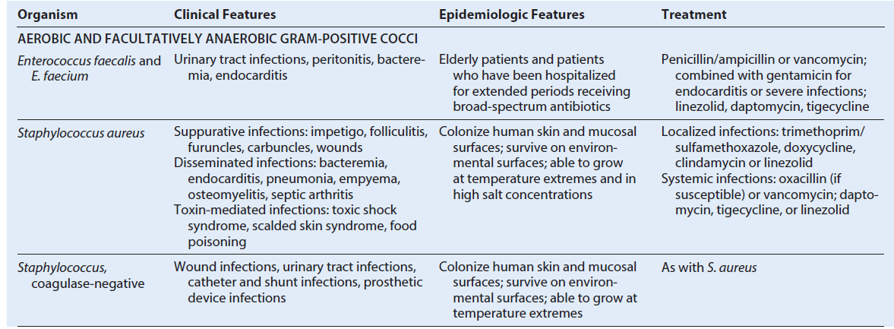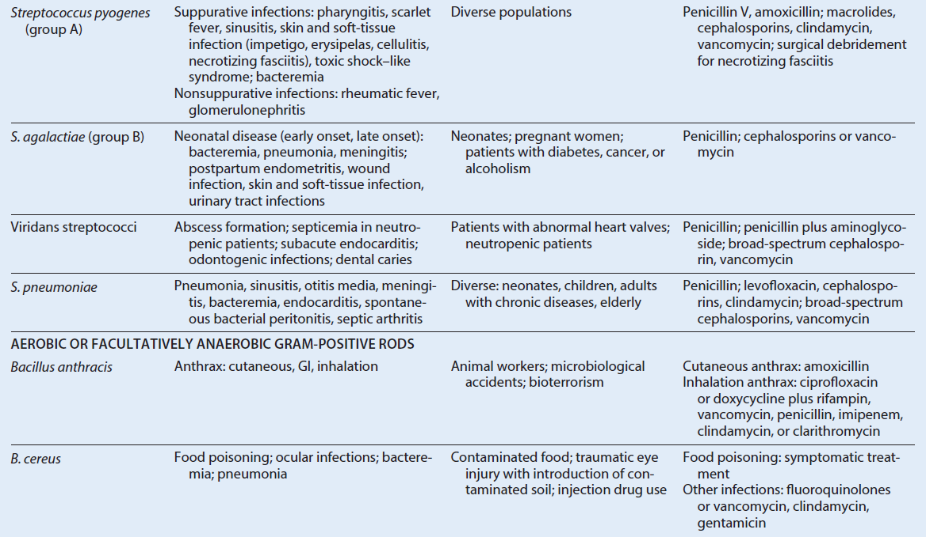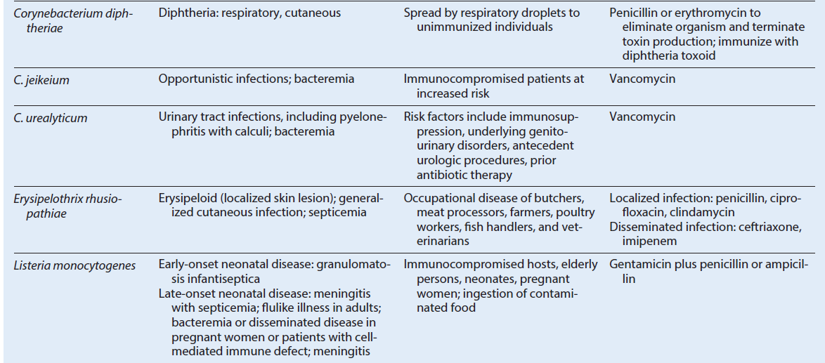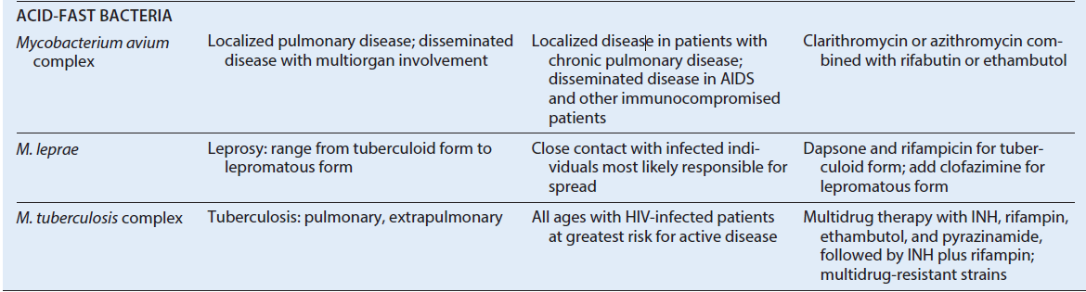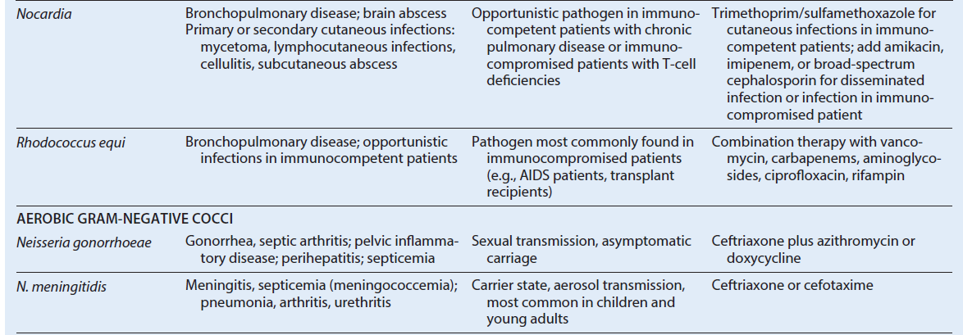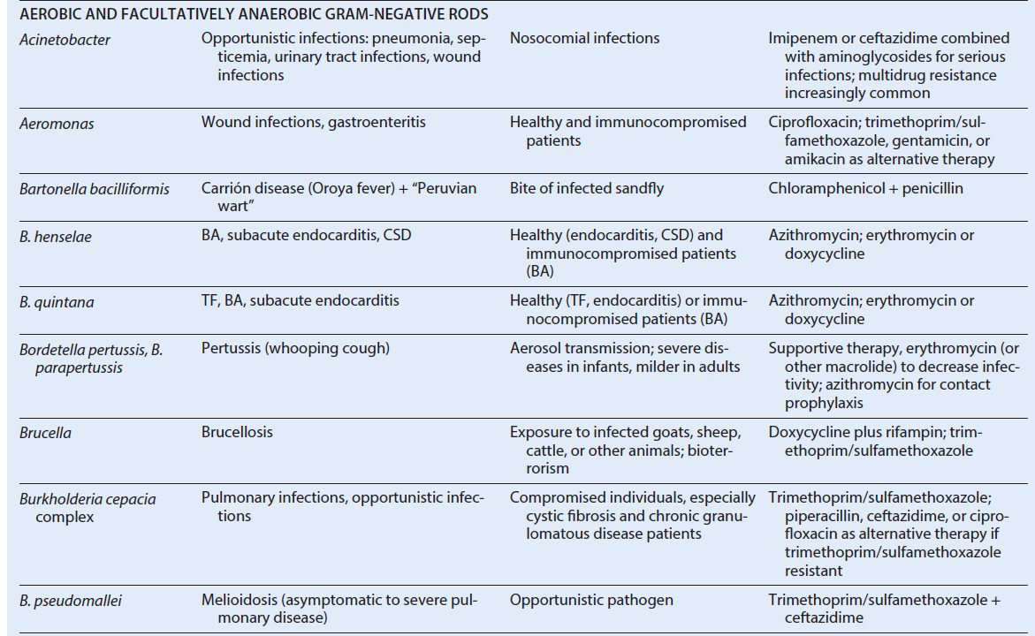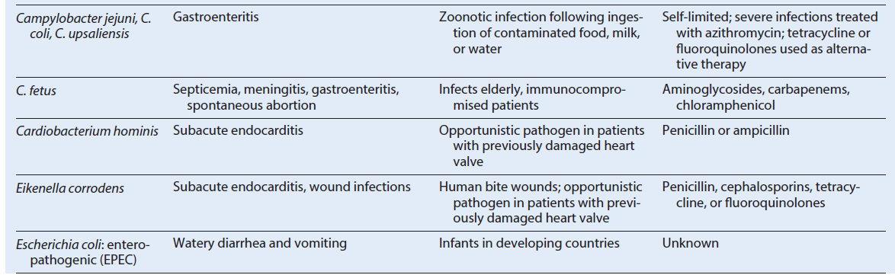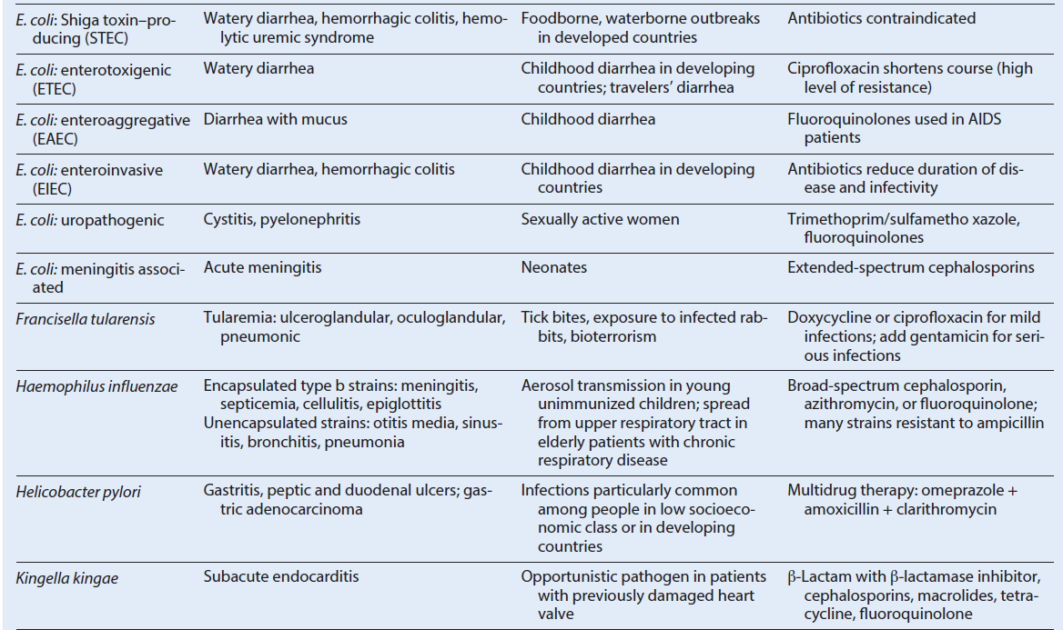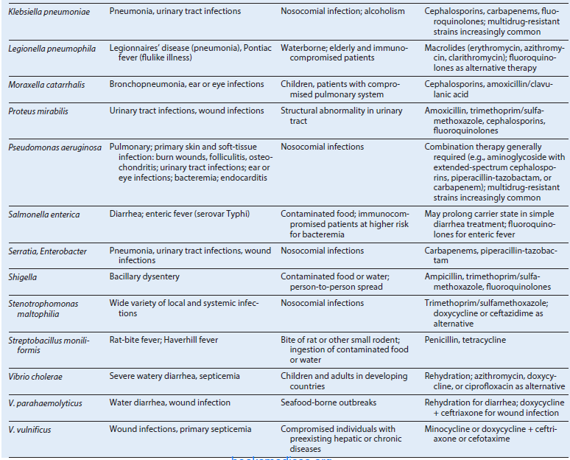
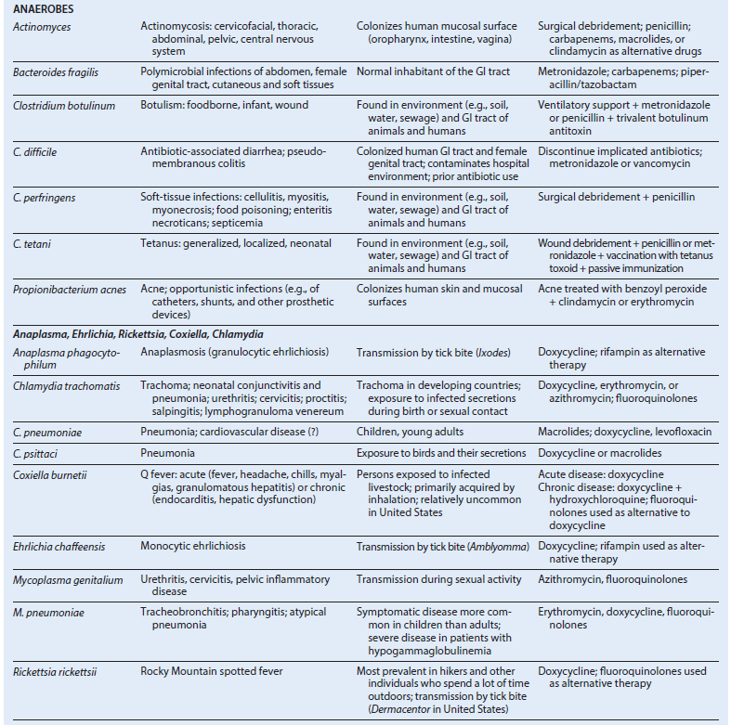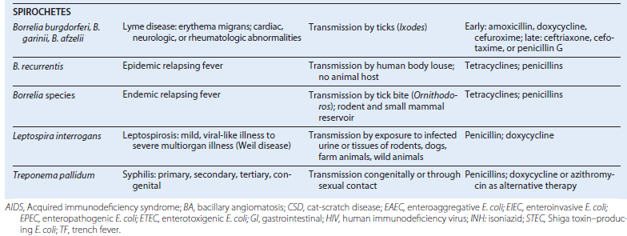
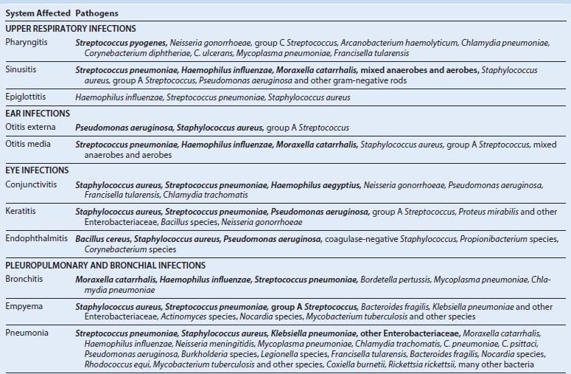
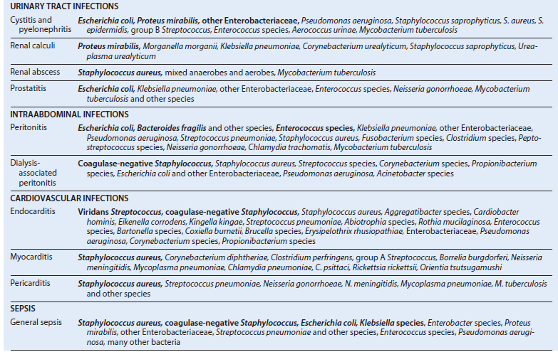
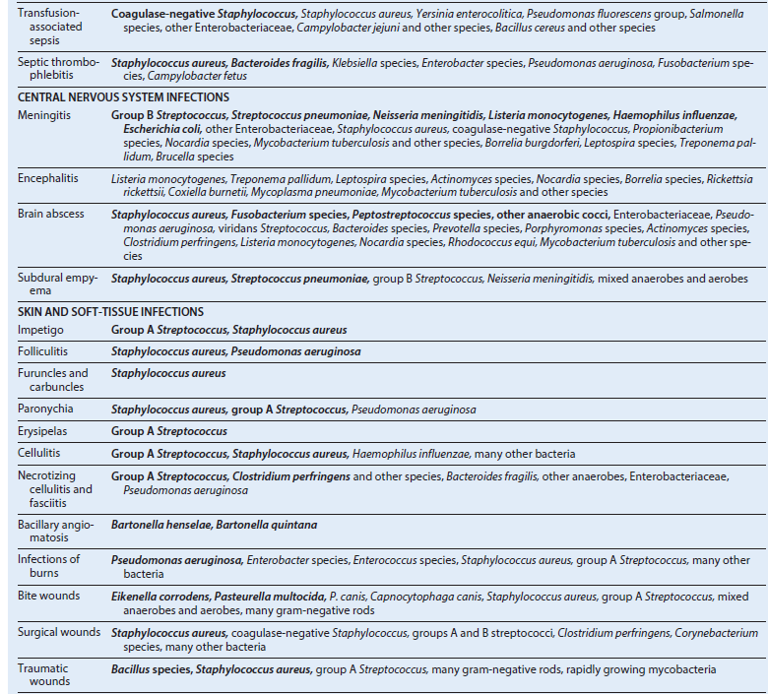
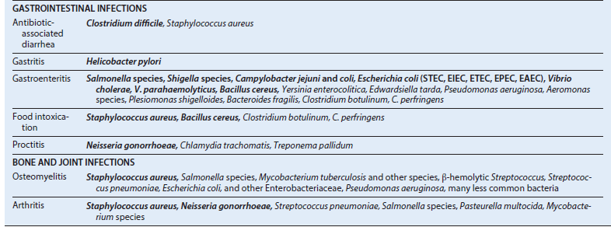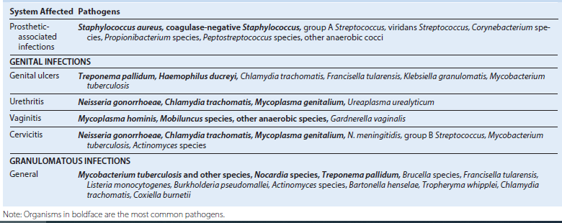

Selected Bacteria Associated with Foodborne Diseases

Aeromonas species Meats, produce, dairy products
Bacillus cereus Fried rice, meats, vegetables
Brucella species Unpasteurized dairy products, meat
Campylobacter species Poultry, unpasteurized dairy products
Clostridium botulinum Vegetables, fruits, fish, honey
C. perfringens Beef, poultry, pork, gravy
Escherichia coli Beef, unpasteurized milk, fruits and juices, vegetables, lettuce
Francisella tularensis Rabbit meat
Listeria monocytogenes Unpasteurized dairy products, coleslaw, poultry, cold-cut meats
Plesiomonas shigelloides Seafood
Salmonella species Poultry, unpasteurized dairy products
Shigella species Eggs, lettuce
Staphylococcus aureus Ham, poultry, egg dishes, pastries
Streptococcus, group A Egg dishes
Vibrio species Shellfish
Yersinia enterocolitica Unpasteurized dairy products, pork
Note: Organisms in boldface are the most common foodborne pathogens.

Selected Bacteria Associated with
Waterborne Diseases
Aeromonas species Gastroenteritis, wound infections, septicemia
Campylobacter species Gastroenteritis
Escherichia coli Gastroenteritis
Francisella tularensis Tularemia
Legionella species Respiratory disease
Leptospira species Systemic disease
Mycobacterium marinum Cutaneous infection
Plesiomonas shigelloides Gastroenteritis
Pseudomonas species Dermatitis
Salmonella species Gastroenteritis
Shigella species Gastroenteritis
Vibrio species Gastroenteritis, wound infection, septicemia
Yersinia enterocolitica Gastroenteritis
Note: Organisms in boldface are the most common waterborne pathogens.

Arthropod-Associated Disease
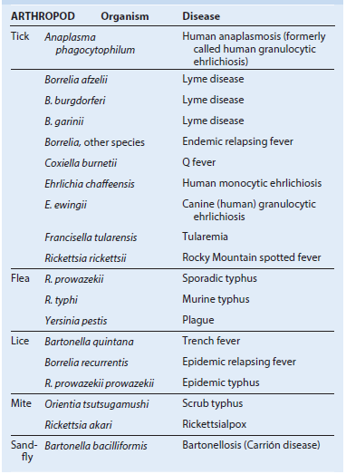

Bacteriology Specimen Collection for Bacterial Pathogens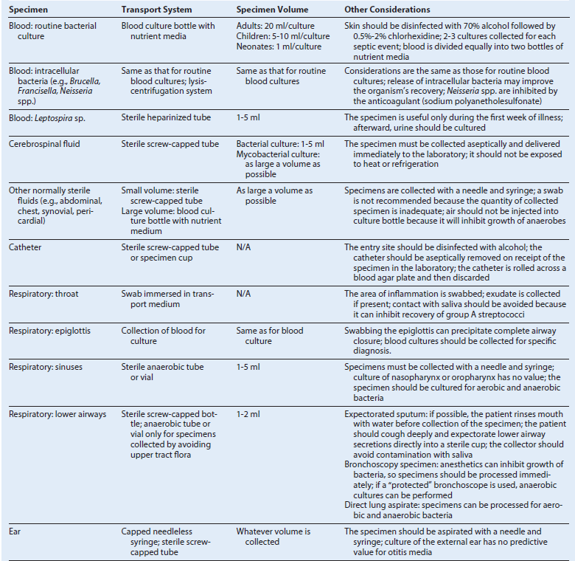 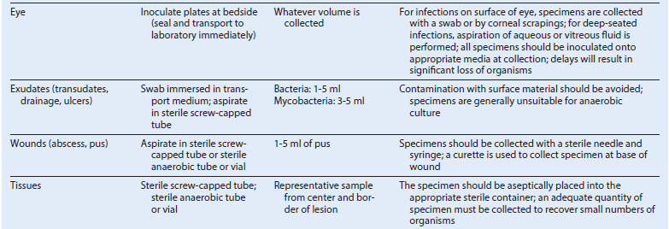 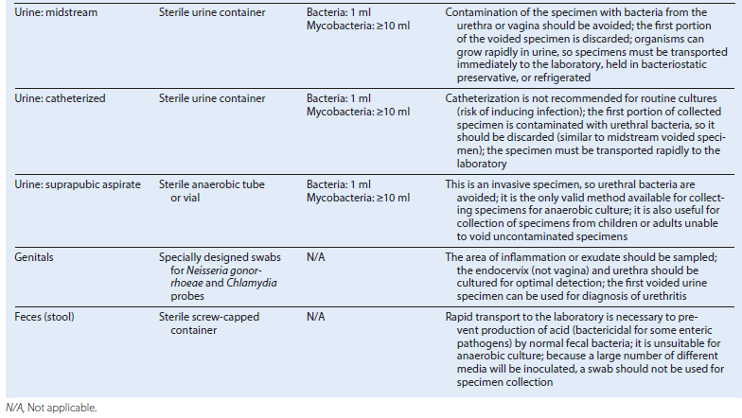

Detection Methods for Bacteria
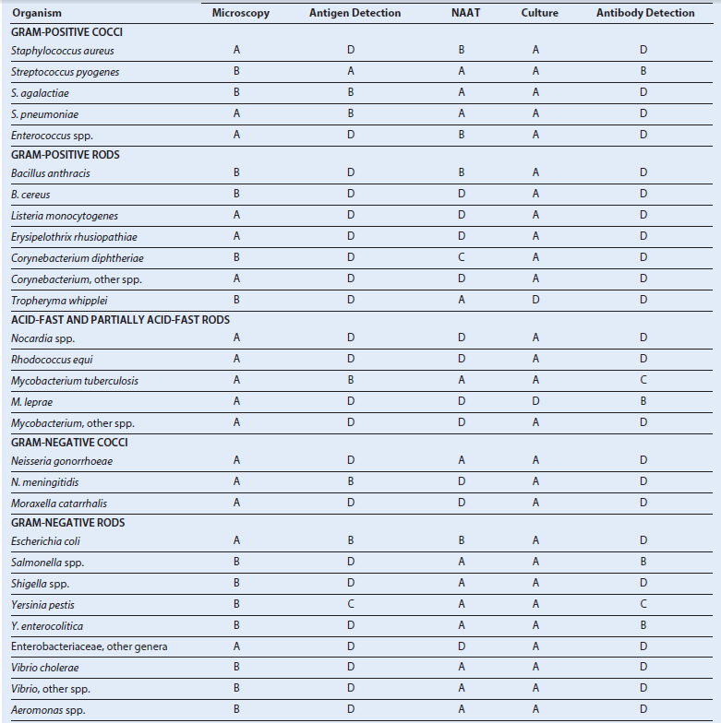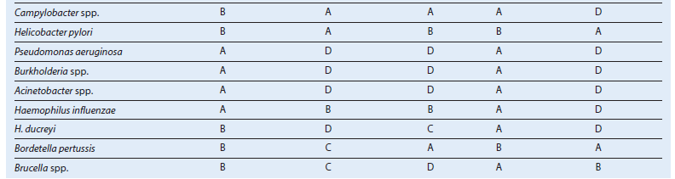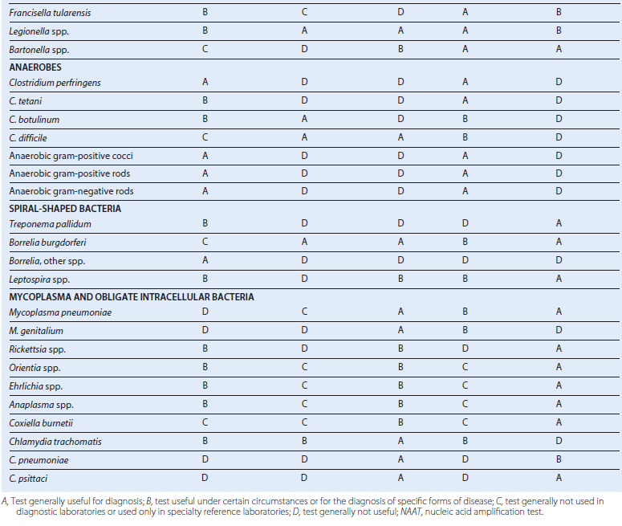

Preliminary Identification of Bacteria Isolated in Culture
